**#FunTimesWithTheTA Build Session  
PulseSim – Photoplethysmograph (Heartbeat) Analog Simulator**

Adapted from: <http://www.instructables.com/id/PulseSim-Photoplethysmograph-Heartbeat-Analog-Simu/> by Orlando S. Hoilett

**Introduction**

Photoplethysmography is the study of the change of volume in an organ using light. Photoplethysmography has famously been applied to measuring the volume of blood in someone’s finger as a method of calculating heart rate. In this technique, the finger is illuminated by an LED (often red, IR, or green) and a photodetector measures the amount of light that passes through the finger. The intensity of light varies with varying blood volume of the finger, which coincidentally corresponds to different phases of the cardiac cycle. The pulse waveform has a very characteristic waveform (Figure 1). It has a fast rise, which corresponds to the systolic phase (ventricles pumping blood to the rest of the body) and a slow drop-off (diastole). Additionally, there is a secondary peak called the dicrotic notch, which corresponds to the closure of the aortic valve, which sends a secondary pressure wave throughout the body. From studying pulse waveform, we can calculate heart rate as well as determine other biometric quantities.

Filters are vary handy circuit components and are an important part of every electrical circuit. Filters can be used to remove unwanted noise, analyze specific parts of a waveform, or even transform some waveforms into another. In this #FunTimesWithTheTA build session, we will recreate the pulse waveform from various combinations and transformations of different electrical signals using filters.

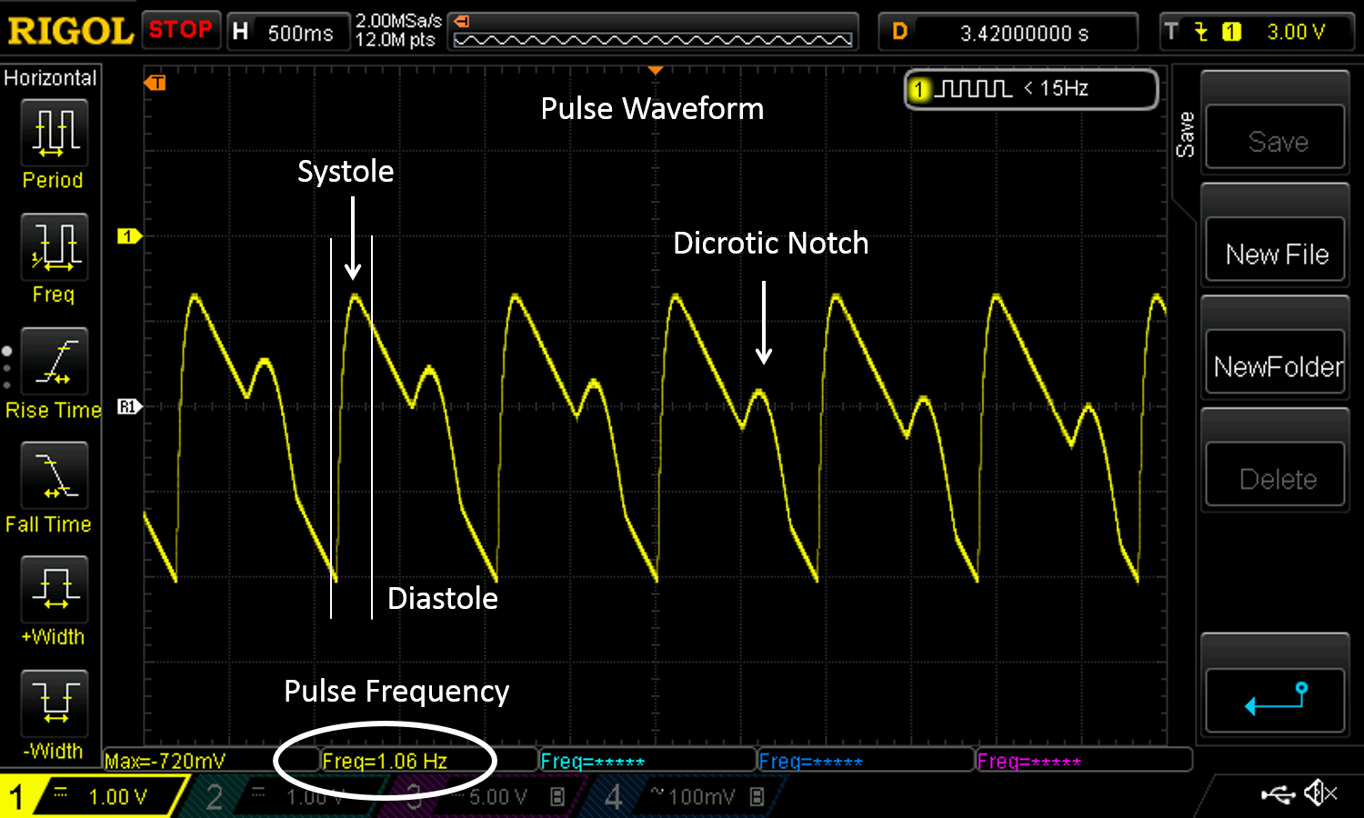

*Figure 1: Example output of PulseSim highlighting the cardiac phases.*

**Objectives**

* Understand the basics of filters low-pass filtering, cut-off frequency, etc.
* Understand the applications of filtering for transforming waveforms from one waveform to another
* Understand the various phases of the cardiac cycle as depicted in a photoplethysmograph
* Have some fun!!

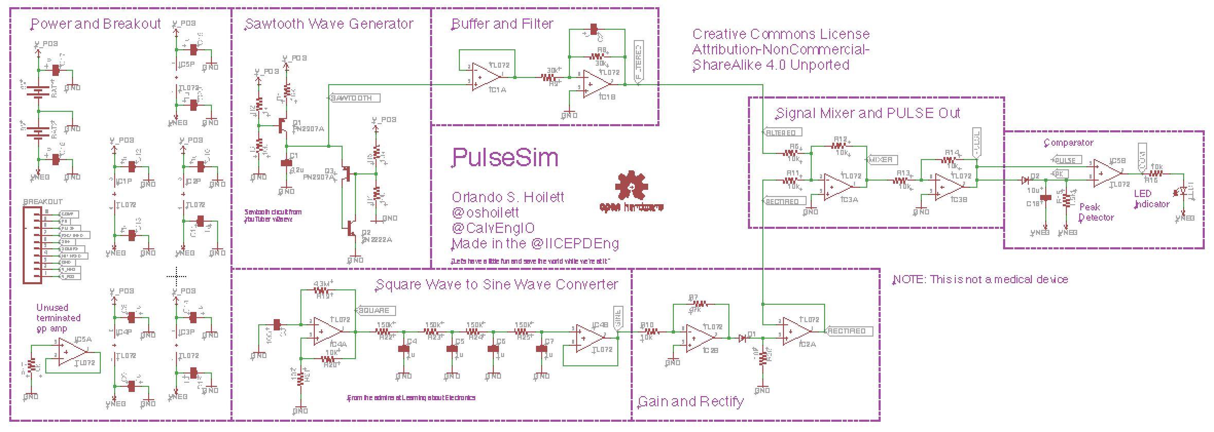

*Figure 2: Circuit diagram of PulseSim.*

**Materials List**

Amplifiers  
5 x TL072 amplifiers

Transistors  
2 x PN2907A transistor  
1 x 2N2222A transistor

Diode  
2 x 1N4148 diode

Resistors  
2 x 1k resistor  
11 x 10k resistor  
2 x 30k resistor  
1 x 47k resistor  
4 x 150k resistor  
1 x 1.5M resistor  
1 x 4.3M resistor

Capacitors  
1 x 100nF capacitor  
5 x 1uF capacitor  
1 x 10uF capacitor  
1 x 4.2uF capacitor

1x Red LED

**Equipment**

* Oscilloscope
* Benchtop supply
* Function generator

**Part #1: Systolic to Diastolic Phase - Sawtooth Wave Generator and Inverter**

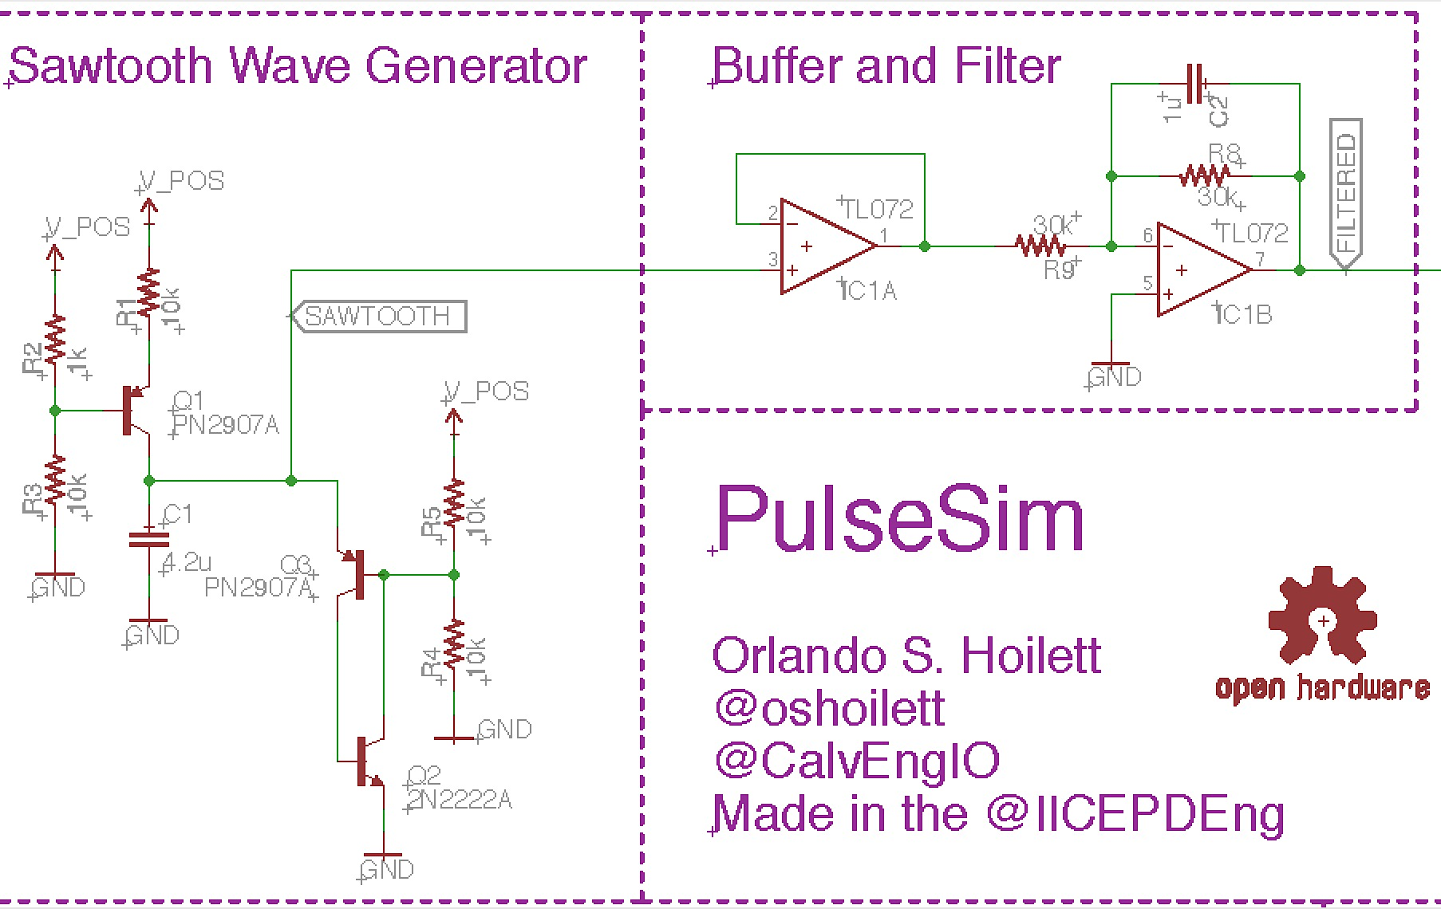

*Figure 3: The sawtooth waveform generator with a buffer and active low-pass filter.*

***Sawtooth wave generator***

For the sawtooth wave generator, we will use three transistors (Q1, Q2, and Q3). Transistors are used essentially as switches to regulate delivery of high current to a circuit. In the schematic, we have a constant current source, which sends a current of about 18.9 µA through the capacitor subsequently charging the capacitor. After about one second (60 Hz frequency, 60 BPM), Q3 and Q2 “turn-on” and rapidly discharge the capacitor. The operation of the three transistors gives us the slow rise and rapid drop-off characteristic of the sawtooth waveform. C1 and the voltage bias set by R4 and R5 set the frequency of our sawtooth waveform. The capacitor charges up to ½ V_POS according to the following equation

$V\left(t\right)=\frac{1}{C}\int_{t_{0}}^{t}{Iτ dτ}+V(t_{0})$ (1)

If our V_POS is 8 V, the 4.2 µF capacitor charges up to 4 V in about 1 second, giving our pulse waveform a frequency of 1 Hz which corresponds to 60 BPM. The schematic was borrowed from YouTuber w2aew and his video titled “#105: More Circuit Fun: Simple 3 transistor sawtooth generator / oscillator.”

***Buffer Amplifier***

A buffer amplifier is used to prevent “loading” of the sawtooth wave generator. A buffer amplifier allows us to deliver the output voltage of the sawtooth wave generator to the next stage, without drawing current away from the sawtooth generator and hindering its operation.

***Active Low Pass Filter***

The sawtooth waveform has similarities to our pulse waveform, but it isn’t exact. First of all, the sawtooth is inverted relative to the pulse waveform. The sawtooth has a slow rise and a fast drop off, while the pulse waveform has a fast rise and a slow drop off. For this reason, we use a low pass filter to round out the high frequency switching of the sawtooth waveform and an inverting amplifier to invert the waveform. This is an “active” filter because we are using an active component, the op amp, in the design. Recall that the cut-off frequency of a low-pass filter is calculated by the following equation

$f_{c}=1/{2πRC}$ (2)

and an inverting amplifier has the equation

$V_{out}=-V_{in}\frac{R_{f}}{R_{in}}$ (3)

In our case, the cut-off frequency of the low-pass filter is determined by C2 and R8 giving us a cut-off of about 5.3 Hz. The value of the cut-off frequency itself is not important. We picked this value to give the “rounded transition” of the pulse waveform. Feel free to play around with the cut-off frequency if you like.

***Testing:***

1. Power the transistors with 8 V and GND.
2. Power the op amps with +/- 8 V from the benchtop power supply
3. Use your oscilloscope to view the output of the buffer amplifier and the active low pass filter to see the transformation of the sawtooth wave into its inverted form. You should obtain waveforms similar to those depicted below.

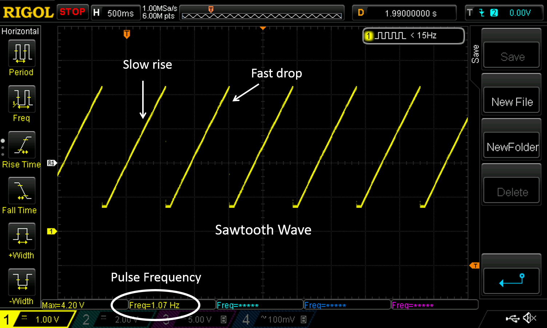

*Figure 4: Example output of the sawtooth waveform generator. Notice the slow rise and the fast drop-off. Frequency of 1.07 Hz set by C1 = 4.2 µF voltage division of R4 and R5.*

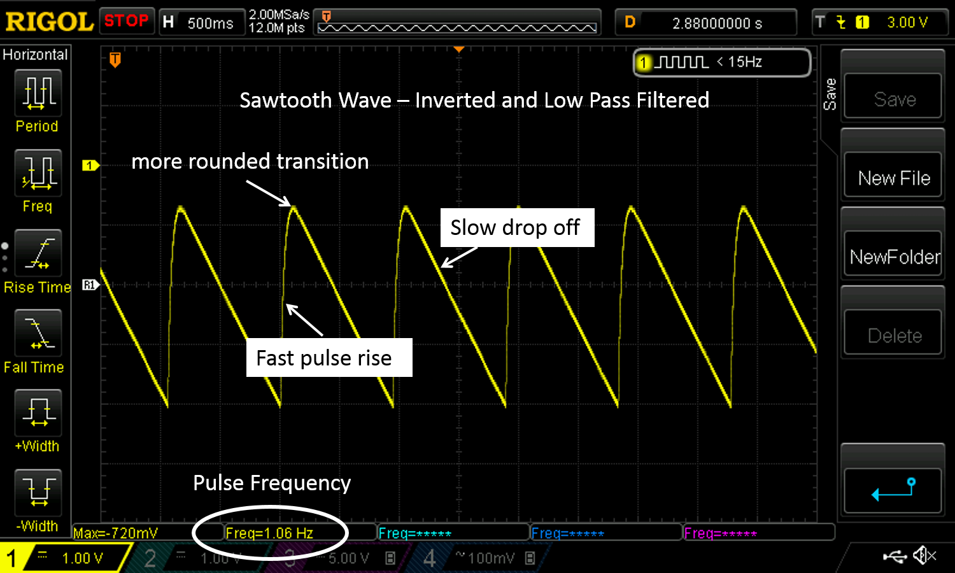

*Figure 5: Example output of the filtered and inverted sawtooth waveform generator. Notice the transition between slow rise and the fast drop-off has been “smoothed-out” by the low-pass filter.*

**Part #2: Dicrotic Notch – Square Wave to Sine Wave Generator**

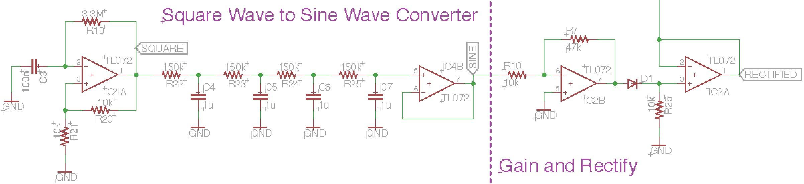

*Figure 6: Schematic of the sine wave generator and rectifier circuit.*

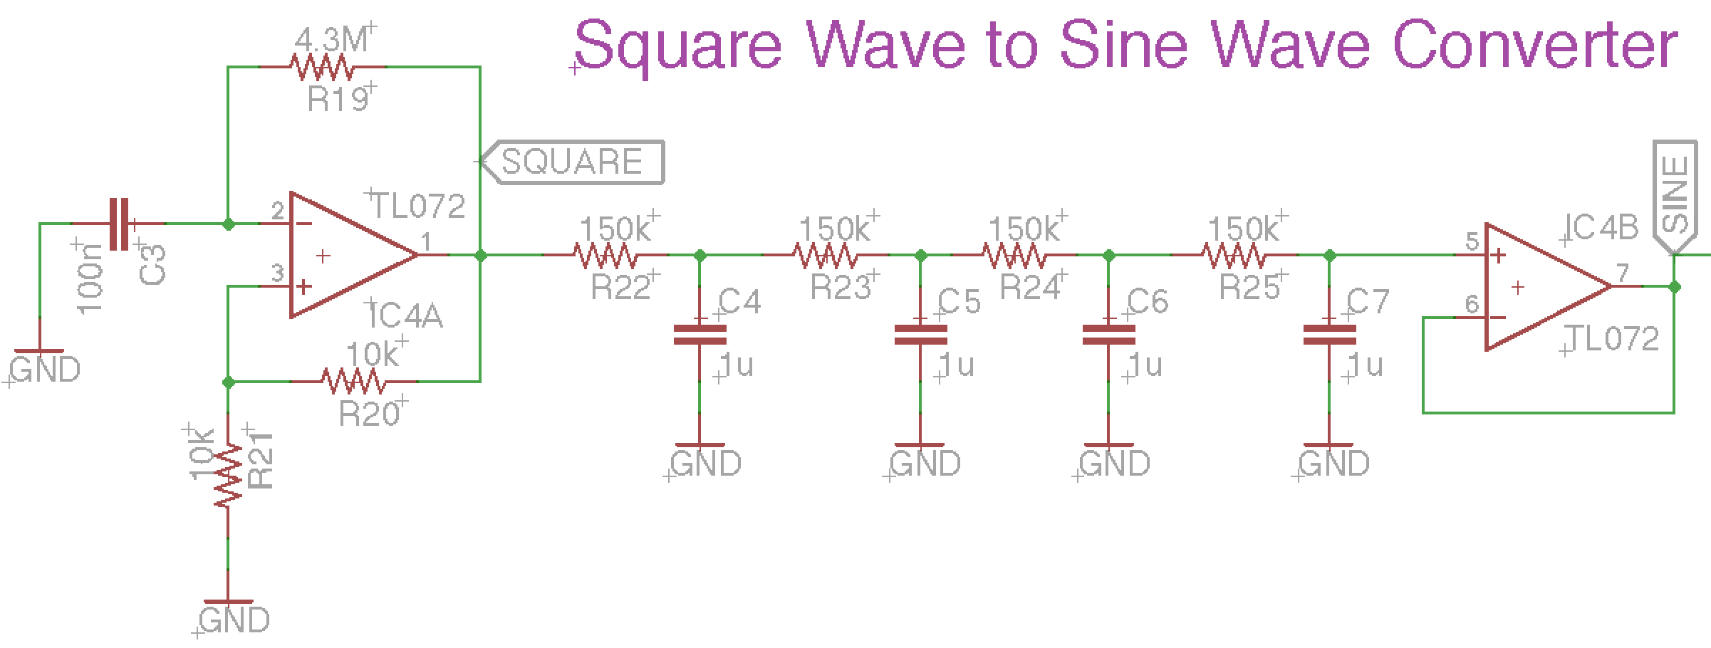

*Figure 7: Square wave oscillator using an astable multivibrator feeds into a 4-pole low pass filter which generates a sine wave. The frequency of the oscillator is set by 2 times the time constant of R19 and C3 (Equations 4 and 5).*

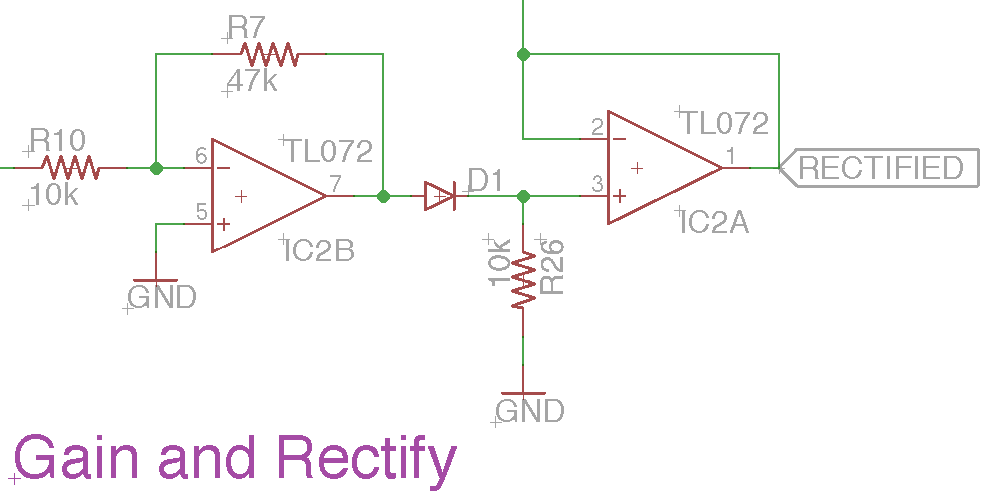

*Figure 8: Inverter and rectifier circuit. The diode blocks negative voltages only passing one half of the sine wave to other stage.*

***Square Wave Generator***

The square wave is generated by an astable multivibrator. In this circuit, the output of the op amp oscillates between two states, high (V+) and low (V-) with a frequency set by 2 times the RC time constant (τ) of R19 and C3. The time constant is set by the equation

$τ=R×C, in Hz$ (4)

$Oscillator Frequency=2×τ, in Hz$ (5)

By using equation 4 and 5, we get an oscillation frequency of

$$Oscillator Frequency=2×τ=4.3 MegaOhms × 100 nanoFarads=1.16 Hz$$

A square wave is a summation of sine waves. As a result, if we filter the square wave at its fundamental frequency, we will generate a sine wave at the output of the filter. We will accomplish the waveform conversion using a 4-pole low pass filter. The filters have a cut-off frequency of 1.06 Hz set by the 150k resistors and the 1µF capacitors, which is close to the fundamental frequnecy of our square wave oscillator (1.16 Hz).

***Rectifier***

To create our dicrotic notch, we only need one half of our sine wave. In order to remove the one half of our sine, we will “rectify” the waveform so that only positive voltages of the sine wave are passed. We accomplish rectification using a diode. A diode is a special semiconductor that only allows current to flow in one direction (positive) and blocks current flow in the opposite (negative) direction. The output of the rectifier is then sent through a buffer amplifier.

***Testing***

1. Power the op amps with +/- 8 V from the benchtop power supply
2. After completing the design, test you circuit by placing your oscilloscope probe at the points labeled, “SQUARE,” “SINE,” and “RECTIFIED.” You should see waveforms as depicted below

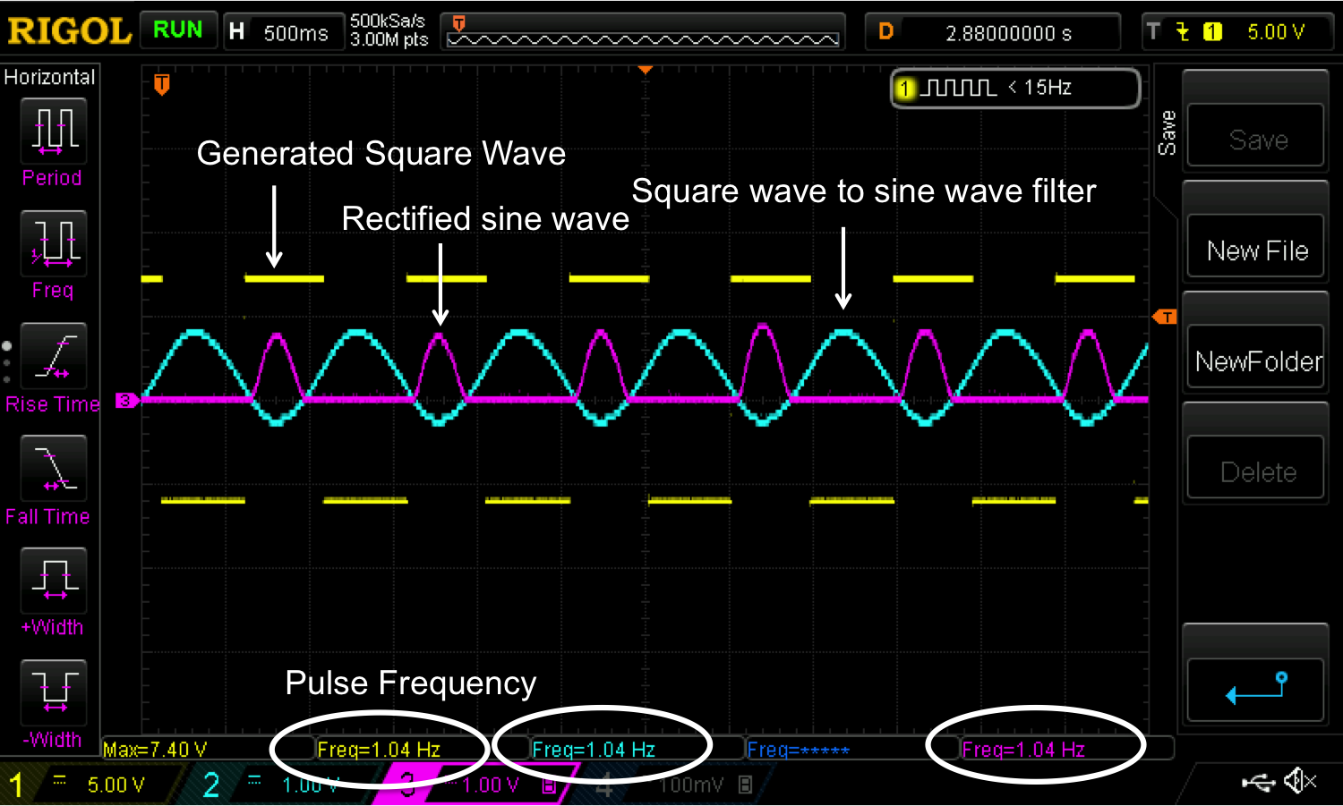

*Figure 9: Example output of the square wave oscillator, the sine wave generator, and the rectified circuit. Notice the frequencies are about 1 Hz which corresponds to a heart rate of about 60 BPM.*

**Part #3: Signal Mixer**

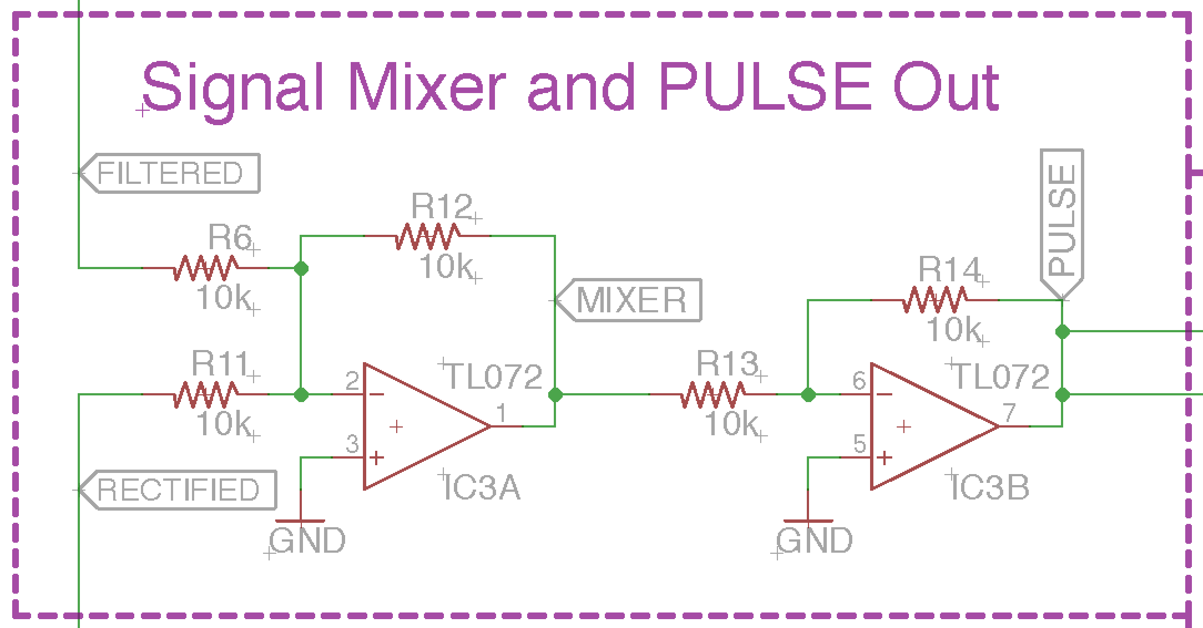

*Figure 10: Schematic of the signal mixer circuit using an inverting summer. The output at MIXER and PULSE will be the generated pulse waveform.*

***Inverting Summer***

An inverting summer, as the name suggests, takes two signals and adds them together, then inverts the output. For example, if we input a sine wave 2*sine(ω t) and 1*sine(ω t) where ω t is equal for both waves, then we should get a sine wave of 1*sine(ω t) at the output. The equation for the output of the inverting summer is

$V_{out}=-(V_{a}\frac{R_{f}}{R_{1}}+V_{b}\frac{R_{f}}{R_{2}})$ (6)

If $R_{f}=R_{1}=R_{2}$ then equation becomes

$V_{out}=-(V_{a}+V_{b})$ (7)

***Inverting Amplifier***

The inverting amplifier takes the input voltage and multiplies the input voltage by the ratio of Rf and Rin, then inverts the sign as depicted by equation 3. For this circuit, we will use the inverting amplifier to simply invert our signal so we can maintain our pulse waveform. As such, we will design an inverting amplifier with a gain of 1.

***Testing***

1. Power the op amps with +/- 8 V from the benchtop power supply
2. Output a 1 Hz, 3 Vpp triangle waveform from the function generator and place it at the input labeled “FILTERED.”
3. Output a 1 Hz, 1 Vpp triangle waveform from the function generator and place it at the input labeled “RECTIFIED.”
4. You should obtain a 1 Hz, 2 Vpp waveform at the output of the both amplifiers. The output at “PULSE,” should be an inversion of the output at “MIXER.”
5. When combined with the other parts, you should obtain waveforms similar to those depicted below.

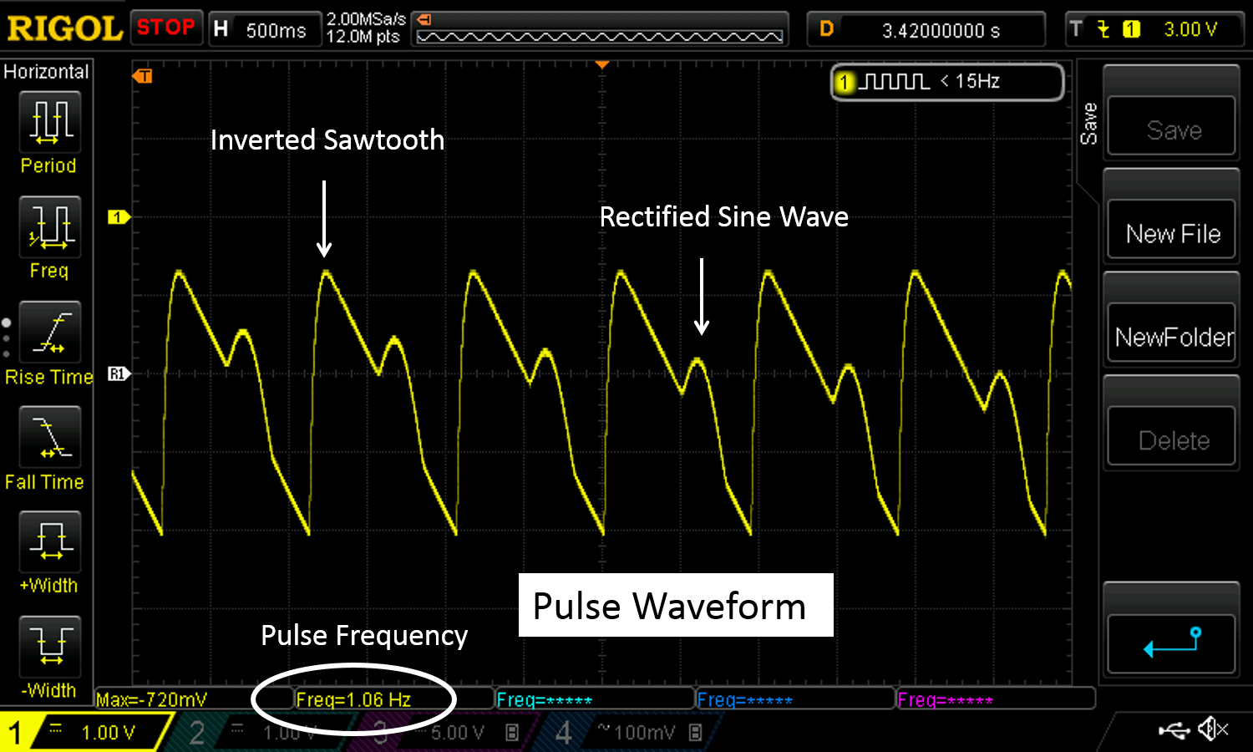

*Figure 11: Example output of the square wave pulse simulator with a frequency of 60 BPM. This is the final output of PulseSim.*

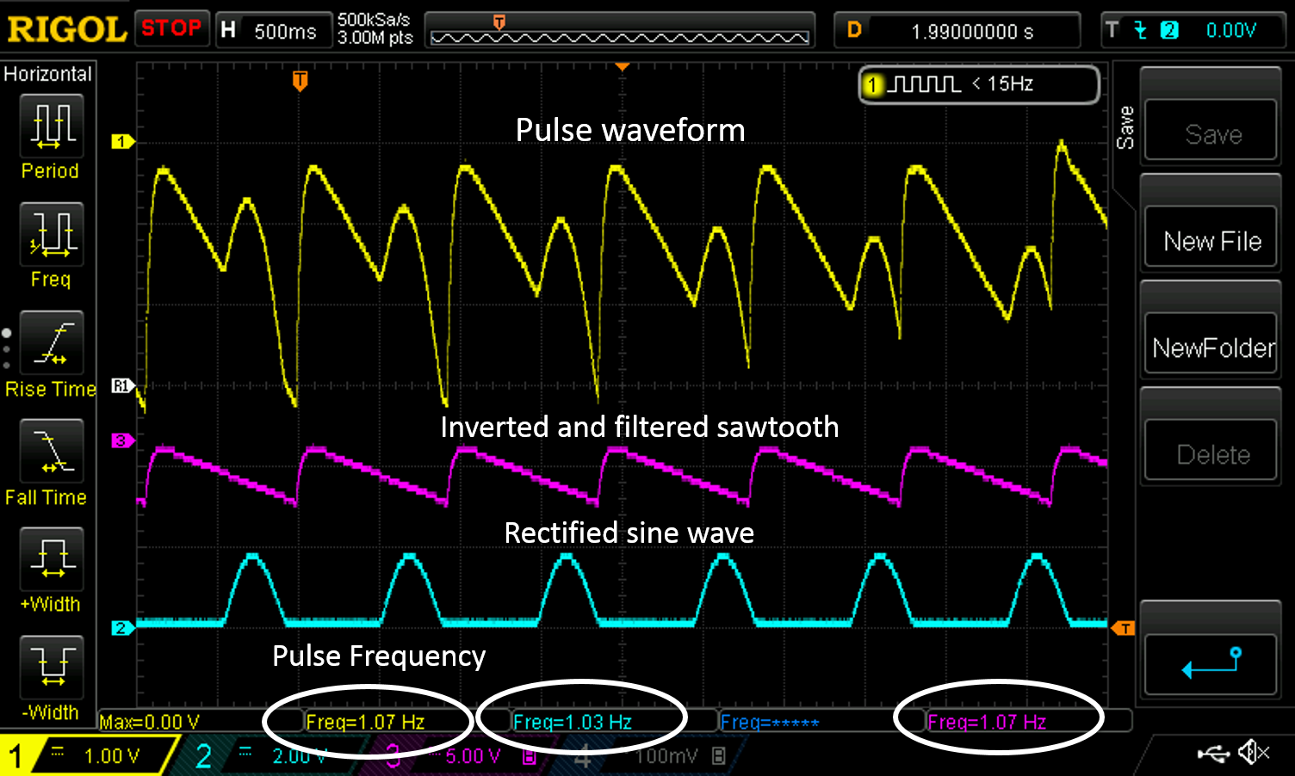

*Figure 12: Example output of the square wave oscillator, the sine wave generator, and the rectified circuit. Notice the frequencies are about 1 Hz which corresponds to a heart rate of about 60 BPM.*

**Part #4: Auto-Threshold Adjuster and Output Indicator**

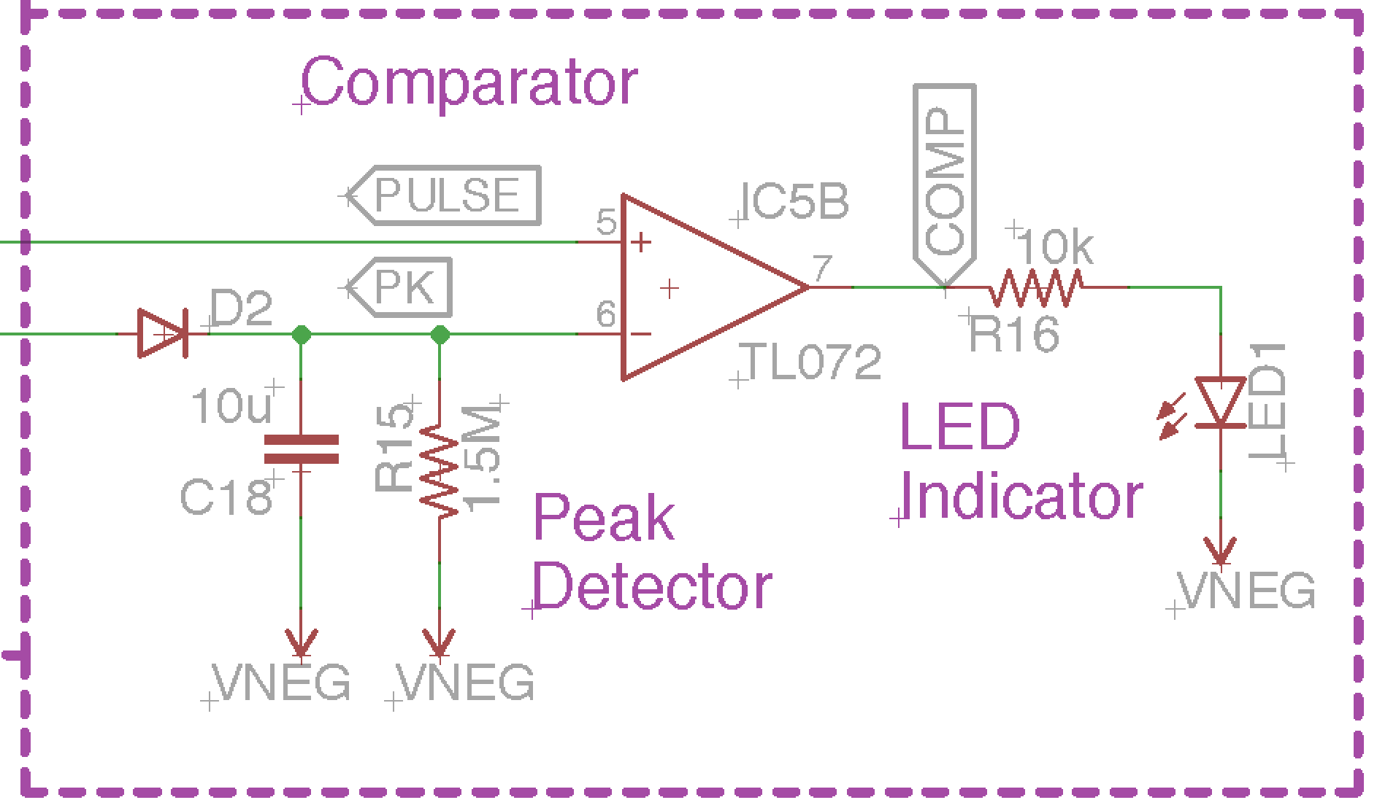

*Figure 13: Peak detector and comparator circuit. The peak detector auto-adjusts a threshold or the pulse output and the comparator lights up an LED when a heartbeat comes through.*

***Peak Detector Circuit***

The peak detector circuit, as the name suggests, finds the peak voltage of the input signal. It accomplishes this primarily with the diode and capacitor. A capacitor stores charge. If we were to connect a capacitor to a 9V battery, then remove the 9V battery, the voltage across the capacitor would remain 9V even with the battery removed. The peak detector utilizes this ability of the capacitor.

A diode is a device that blocks the flow of current in the reverse direction. This prevents the capacitor from discharging meaning the capacitor would hold the 9V charge indefinitely. We do not want the capacitor to hold charge indefinitely, so we place a resistor in parallel with the capacitor. The resistor discharges the capacitor at a rate equal to the RC time constant (τ) of the resistor-capacitor circuit where,

$τ=R×C$ (8)

We set our RC time constant so that the capacitor holds the charge long enough to set a relatively level threshold with only small change in voltage before our next pulse.

***Comparator and LED indicator***

A comparator compares the voltage between an op amp’s two inputs (inverting and non-inverting). The output of the comparator is determined by the following equation

$V_{out}=A_{OL}\left(V_{+}-V_{-}\right), with V^{-}≤Vout ≤V^{+}$ (9)

Where AOL is the open loop gain of the amplifier, which we will assume to be infinity, V+ is the voltage at the non-inverting pin, and V- is the voltage at the inverting pin. Do not confuse V+ and V-, which are the supply voltages of the op amp and V+ and V-, which are the voltages at the non-inverting and inverting input respectively. In short, if the voltage at V+ is higher than V-, the output of the amplifier will hit the positive rail (V+). If the voltage at V- is higher than V-, the output of the amplifier will hit the negative rail (V-).

We connected the pulse output to the non-inverting pin of the comparator and the peak detector to the inverting pin. If the pulse output voltage exceeds the voltage of the peak detector, the output of the comparator is positive which lights our LEDs indicating a heartbeat (systole). If the pulse output does not exceed the voltage of the peak detector, the LEDs do not light indicating diastole.

***Testing***

1. Power the op amps with +/- 8 V from the benchtop power supply
2. Output a 1 Hz, 3 Vpp sine waveform from the function generator and place it at the inputs labeled “PULSE” and “PEAK.” The LED should pulse momentarily every one second.
3. When combined with the other parts, you should obtain waveforms similar to those depicted below.

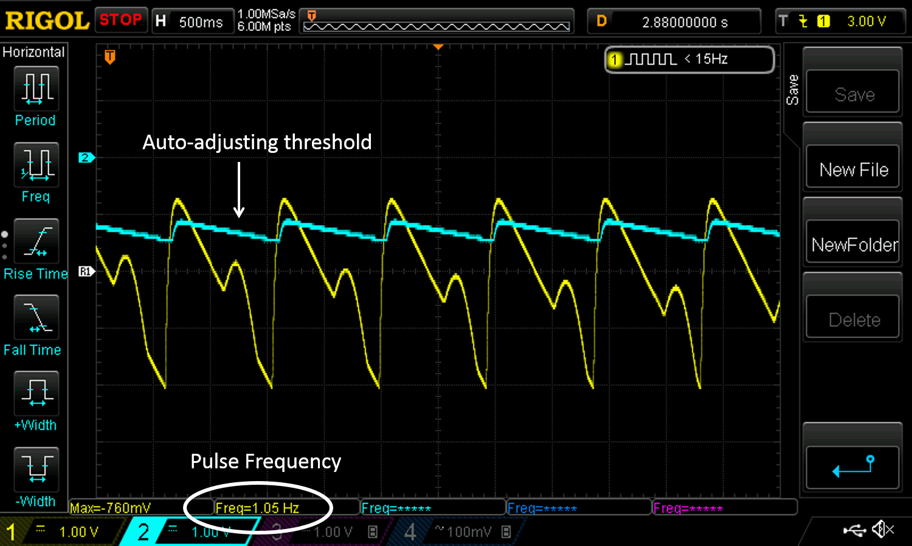

*Figure 14: Example output of the pulse output and auto-adjusting threshold. Notice the threshold is high enough to distinguish systolic phase from the dicrotic notch.*

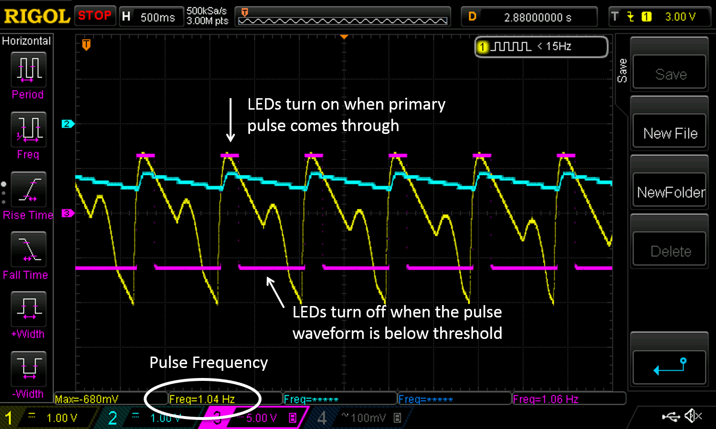

*Figure 15: Example output of the pulse sensor with the threshold and LED output stimulus. The LED is lit when the pulse output exceeds the threshold level.*